(Approx. 2295 words)

INTERNET RADIO ON THE ROAD
Enjoy streaming radio stations while driving
By John Krout, Presenter & Newsletter Contributor
Potomac Area Technology and Computer Society (PATACS)
www.patacs.org
jkrout.apcug.presenter (at) gmail.com

INTRODUCTION

At least for those of us who are fully vaccinated, the pandemic is arguably history. So, travel is feasible again. No doubt many are planning road trips like I am.

This article explains how you can use your smartphone to listen to interesting music in the styles of your choice on Internet radio stations. An interesting aspect of the Internet is a geographically scattered audience can be large enough to attract and support Internet radio stations. So, look for Internet radio stations consistent with your music interests, and you can find them.

The technical process of sending digital audio for broadcast-like mass consumption on the Internet is called audio streaming. Each Internet radio state Web page publicly announces one or more URLs for receiving the station's audio stream. Sometimes the Web site for an Internet radio station lists multiple streaming URLs, one for each of several different computer-based playback apps such as WinAmp, QuickTime, Windows Media Player, and so forth.

With some research, a smartphone, and an appropriate app, you can find and play to your heart's content Internet radio stations for your tastes while you drive around the US, even if your musical preference is far from average. My musical preference, for example, is far from average.

GETTING STARTED

I got started with this topic when I visited the Web site for my favorite (and at the time my only) Internet radio station, Aural Moon (www.auralmoon.com), in July 2021. That site plays progressive rock, meaning songs similar to those released in the 1970s by Genesis, Procol Harum, Yes, Emerson Lake & Palmer, Chicago, Styx, Led Zeppelin, the Who, and many other bands.

Although the progressive rock genre dominance of FM rock radio in the US pretty much ended in the 1980s, that genre has certainly not disappeared. Many bands and individuals released songs in that genre from the end of the 70s through today and continue to do so. However, most of my favorite 70s progressive rock artists have retired or no longer create complex tunes like those they composed while young. The current progressive rock artists are mainly new to me. That's fine by me; I like to hear new tunes by unfamiliar artists occasionally.

The Aural Moon home page does have links for listening to Aural Moon instantly, without leaving the home page, using some playback app built into the home page. Aural Moon

supports various bit rates for music delivery; higher bit rates are better, producing more accurate and detailed sound. On that station, the highest-rate links are reserved for paid subscribers.

The Aural Moon website provides a URL for listening to their station at a decent bit rate, not the highest, without using a Web browser. Not only that, but the website also includes a page providing links to other Internet radio stations that play progressive rock tunes.

That station list page caught my attention. I found a few 24/7 stations there. I did some further research online and eventually found a total of seven Internet radio stations that play progressive rock 24/7.

Separately, I found an extensive list of Internet stations for jazz. And I now have access to lists for just about any music genre I could name and some I could not have named. Read on for details.

The basic process for preparing to listen to Internet radio on the road is:

- Find Internet radio stations you will enjoy on the road.

- For each station, find its audio streaming URL.

- Find a smartphone app that can play Internet radio stations.

- Put the URL for each radio station into the smartphone app. This is roughly like setting the physical quick selection buttons on your 1970s car radio to any local broadcast radio stations you prefer.

Eventually, I found a shortcut that eliminated the need to find streaming URLs and added quick selection buttons in my smartphone app.

FINDING INTERESTING INTERNET RADIO STATIONS

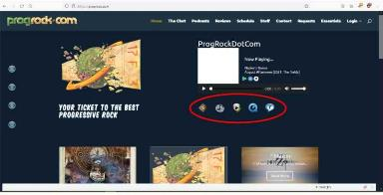
It is not difficult to find Internet radio stations using a Web browser and Google or another search engine. First, search for "internet radio" followed by the name of the music genre you prefer.

Initially, the search engine will list each station's home page. You can see the home page of a
station named ProgRock.com in Illustration 1

Illustration 1. I have circled the links for streaming playback using (left to right) WinAmp, iTunes, Windows Media Player, QuickTime, and RealPlayer. For a first audition of the station, try playback using its own built-in player or a player on your computer to make sure you enjoy its music selections.

Additionally, I found an Android smartphone app with a great list of stations organized by music genre. Read on.

FINDING A STATION'S STREAMING URLS

Sometimes the audio streaming URLs on the home page for a station are not obvious. To find streaming URLs, I hovered my mouse pointer over each of the home page links to listen to a station's audio stream. When that is done, the URL for the link appears in the lower-left corner of the Firefox web browser that I use.

For instance, in the ProgRock.com page in the illustration, the URL revealed for WinAmp was:

https://psn3.prostreaming.net:2199/tunein/mmonfo01.pls

The character to the left of 1 near the end of the URL is a zero, not an uppercase o.

I found Android apps (see below) that will play that audio stream URL. In addition, those apps will play streams of stations featuring other music genres too.

Another Internet radio station home page had two links labeled "listen with your own app." So, I hovered the mouse pointer over one of those to find the streaming URL. Like Aural Moon, these stations have an app inside their home page to play the station's audio stream. While using a web browser on a computer, it is easy to bookmark each station's Web page for later listening.

While on the road, I think using a Web browser to access a radio station page and clicking on the page's built-in player is safe.

Below you will learn how to use an Android smartphone streaming player app to create quick station selection buttons, a much easier way to access or change stations on the road.

FINDING A STREAMING PLAYER APP

I started by using VLC, a flexible and powerful media player app for Android and iOS. While doing so, I ran into a curious limit of the Android version of VLC. VLC can permanently remember only a few streaming URLs.

In VLC version 13e15aa9D for Android, released January 20, 2021, the user can start playing an audio stream by tapping the More button at the bottom right corner of the

the main VLC screen. A NEW STREAM button appears; tap that, and a Streams page appears with a field for entering the streaming URL of your choice. It also lists up to five streaming URLs you entered in the past. You can see an example of the VLC Streams page in illustration 2.

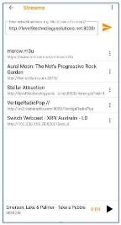
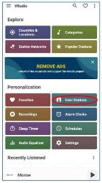
When you reach the VLC ceiling, which is five streaming URLs, you can continue to start new streams using the process described above, but VLC will not remember each unique streaming URL unless you first delete one of the five.

Like I mentioned above, my research has found seven stations so far. I need an app with a memory ceiling greater than five.

I tried two other Android apps. The first of those two did not support playback of streaming URLs, but the second one did. It is called VRadio. I used VRadio v2.0.7 on my Samsung Galaxy S10 running Android 11 to prepare this article. You can see its

Illustration 2 Illustration 3

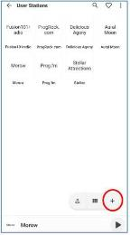
home screen in illustration 3. I circled the User Stations button because that button enables you to enter and playback streaming URLs.

Tap that button, and the User Stations screen appears, as shown in illustration 4. You can see I have already added seven stations. To add a station's audio streaming URL and station name, tap the + button circled in the lower right corner of the User Stations screen. That add-station process ends up creating another station button on the User Stations screen.

To play a streaming station, tap the station's button in the User Stations screen.

During music playback from a station's stream, the app displays the artist’s name and the song name, if that info is transmitted by

Illustration 4

by the station as text. Some stations also provide the album title. So, you can learn the name of an unfamiliar artist whose song charms you.

If you really enjoy a local broadcast radio station, and that station also provides a streaming URL, you can use this technique to listen to your local station while your car is outside the station's broadcasting range.

When a station button is tapped in VRadio, playback often is preceded by a full screen advertisement, but so far, I have found I can terminate an ad within five seconds.

To eliminate ads, there is also an option to pay either a subscription fee or a single-time fee, which I would recommend as a safety measure for any serious button pushing while on the road.

KEEP YOUR ANDROID SCREEN TURNED ON

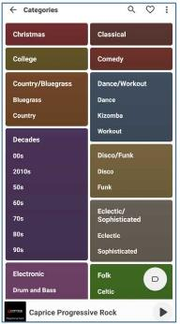
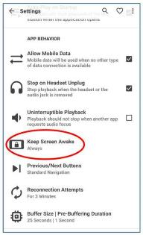
Another safety risk is the need to unlock the screen while driving. Instead, before hitting the road, you can use Vradio to lock your screen on.
Illustration 5

At the top right corner of the Vradio screen, tap the 3-dot icon. A menu drops down; select the Settings choice in that menu. A very long Settings screen appears.
Scroll down to the APP BEHAVIOR settings group, and find the Keep Screen Awake setting, circled in illustration 5.

Tap that setting. A menu
appears, containing three choices: Never, Only while charging, and Always. Tap the Always Choice. The menu disappears, and the choice appears below the setting title.

CATEGORIZED STATION LISTS PROVIDED BY VRADIO

Illustration 6

The VRadio app also includes extensive lists of Internet radio stations by music genre. Take another look at illustration 3. In the upper right corner, there is a Categories button. Tap that, and the screen shown in illustration 6 appears. It is a very long screen, far longer than the top part shown in the illustration. The screen is divided into sections, and each section has a heading, such as the Decades section on the left.

I scrolled down and found a Rock section. In that section, I found a Progressive Rock choice. So, I tapped that and found a long list of progressive rock stations, including three of those I had already discovered through my prior research. To play any station in the list, tap its name.

I browsed the stations I had not already found and auditioned each one. I identified a few that I liked; I chose those that operate 24/7 and provide the artist's name and song title as visible text during their streams. The technique for marking each station as a Favorite is very simple and does not require determining the streaming URL for each station. Doing so also produces a quick selection button for each station.

When you play a station in a VRadio categories list, the station name appears at the bottom of the screen. Tap that bottom field, and a full-screen player appears with additional info about the station, as well as a Heart icon in the lower-left corner. You can see an example of that full-screen player in illustration 7. Again, I circled the Heart icon.

Tap the Heart icon, and the station is added as a Favorite in VRadio.

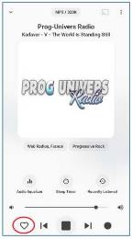

Illustration 7

There is a Favorites button on the VRadio main screen, the heart in the upper right corner. You can see that heart button in illustration 3. I tapped that button and saw a consolidated set of buttons for all that I had added as User Stations plus all that I had added as Favorites.

Therefore, Favorites is the place to go for a complete set of quick selection buttons to use while on the road.

I did the same browse-audition-mark Favorite activity using the Jazz station list in VRadio, which turns out to be a very long list. I found one Jazz-Rock station that I added as a Favorite.

APPS FOR APPLE DEVICES

Try the TuneIn app, a free download from the App Store. It, too, contains an extensive stations list. It starts with a full-screen ad for a premium subscription to listen to the major networks, but otherwise, it offers free access to Internet radio stations. I used the app on my ancient, retired iPhone 5 and iOS 10.2.4 to search for Aural Moon, and the app found that station. Any Internet radio station you find and like can be saved by tapping the Heart icon in the player screen's upper right corner.

According to a Macworld review I read online, TuneIn for the recent iOS versions also has a Car mode that displays quick selection buttons for Favorite stations. Unfortunately, I could not find that feature in the version for iOS 10.2.4.

FINAL NOTES

On the VRadio main screen, there is also a Station Networks button. I browsed the

alphabetic list of station networks provided by that button and found one with a pun of El Doradio.

ABOUT THE AUTHOR: John Krout has been writing about creative uses of personal computers since the early 1980s. Now he also covers smartphones, tablets, and digital cameras. He is retired after a long career as a software engineer for various federal contractors. He lies in Arlington, VA, with his son, many computers and cameras, and too many cats.

